Memorandum

To | Monaro RFS Members
From: | Tim Ingram L&D Officer
Subject: | Monaro Training
Date: | 23rd March 2020 | File No.

- Unfortunately, given the current/ongoing and increasing restrictions to any gatherings due to the Coronavirus, all Monaro Rural Fire Service training will cease until further notice. This will include both locally organised brigade training and District Training as per the Monaro Training Calendar.

- For new members that wish to complete Bush Firefighter training, please complete Volunteer Induction SI, Safety Induction SI and Bush Firefighter BF theory online as per FUEL.

- In the event that training may commence later in the year, priority will be given to new members that have completed the three online courses as listed above.

- The FUEL user guide is outlined below.

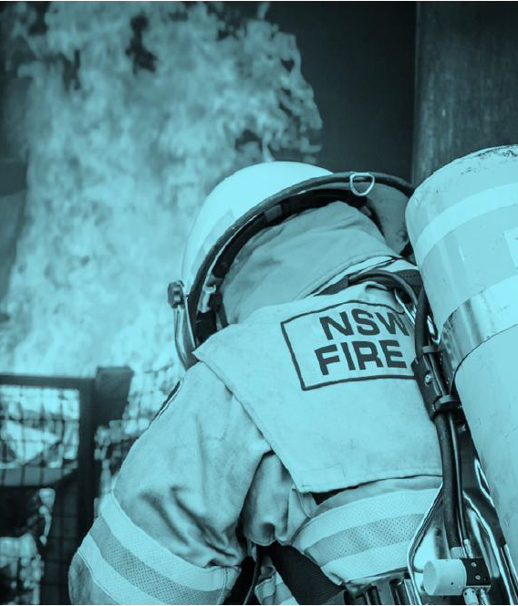
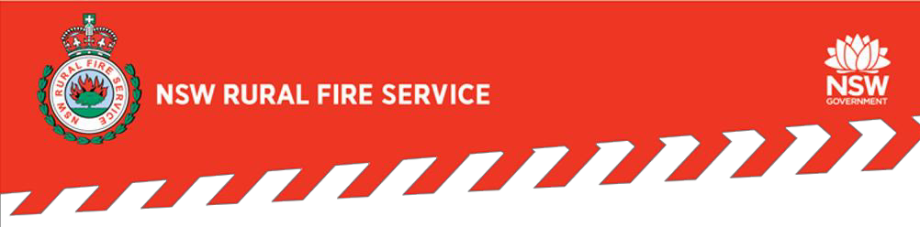
FUEL
Online learning user guide
1.0

- Equipment required 3
CONTENTS
- Before you begin 3
- Accessing Fuel 3
- Logging in and out 4
  - Member log in 4
  - Guest log in 4
  - Commercial Training log in 5
  - Log out 5
- Accessing and completing courses 5
  - Members 5
  - Guests 8
- Help 10
- Frequently Asked Questions 10
  - Fuel 10
  - Bush Firefighter (BF) modules 11
- Feedback 12
- Appendix A – Fuel interface (Members) 13
- Appendix B – Fuel interface (Guests) 15
- Appendix C – MyRFS password reset 17
- Appendix D – NSW RFS Training Framework 18
- Appendix E – Skill cards 19
- Appendix F – BF online course completion Vs face-to-face course completion 20
- Appendix G – The Knowledge Hub 22

Equipment required
To participate in NSW RFS elearning you need:
› Internet connection
› Web browser e.g. Internet Explorer, Mozilla Firefox, Google Chrome, Safari (Google Chrome is recommended for optimum quality)
› Speakers or headphones
› MyRFS username and password (or network log in for staff)
!
If you have forgotten your username or password, please go to Appendix C to
reset before trying to log in to Fuel.

You must use your MyRFS log in to log in to Fuel

Before you begin
There are some important things to note:
› Your Internet connection: An Internet connection is required to use Fuel. It is recommended that you access Fuel using a high-speed internet connection. You may experience slow loading times when using 3G and 4G connections.
› Turn off your pop-up blocker: Some activities and resources in Fuel launch into a pop-up window. Turn the pop-up blocker off in your web browser before you begin.

Internet Explorer
To turn off the pop-up blocker, click Tools > Pop-up Blocker > Turn Off Pop- up Blocker.

Accessing Fuel
You can access Fuel in any of the following ways:

1 | MyRFS | Go to www.myrfs.nsw.gov.au > click ‘Fuel’ icon on left hand side of home page
2 | Staff Intranet | Go to http://intranet/ > scroll down right hand side of home page to ‘Live Applications > click ‘Fuel’
3 | Direct web address | Go to http://fuel.rfs.nsw.gov.au

Logging in and out
Whether you access Fuel via MyRFS, Staff Intranet or the direct web address you will be directed to the Fuel log in page and asked to type in your username and password.
The username and password required is the same as your MyRFS username and password (or network login for staff).

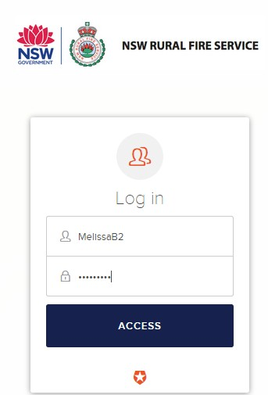
Member log in
1

2
3

2. Type in your password.
Remember this is the same password you use for MyRFS.
Forgotten your password? Click on the ‘Password reset’ button highlighted below.
(See Appendix C, p.17 for more details)

1. Type in your username.
Remember this is the same username you use for MyRFS.

Guest log in
Commercial training log in

Guest log in
Password reset

3. Click the ‘Access’ button to enter Fuel.
A guest log in button has been created to assist potential members complete their inductions online, while waiting for their membership paperwork to be finalised. Guests do not need a username or password.
Guest log in
1

1. Click the ‘Guest log in’ button to enter Fuel.

Commercial Training log in
The NSW RFS offers Commercial Training to external organisations. The Commercial Training team will issue participants with a username and password to access Fuel. For all enquiries email corporate.training@rfs.nsw.gov.au

Log out
To log out click the ‘Log out’ text in the top right hand corner.
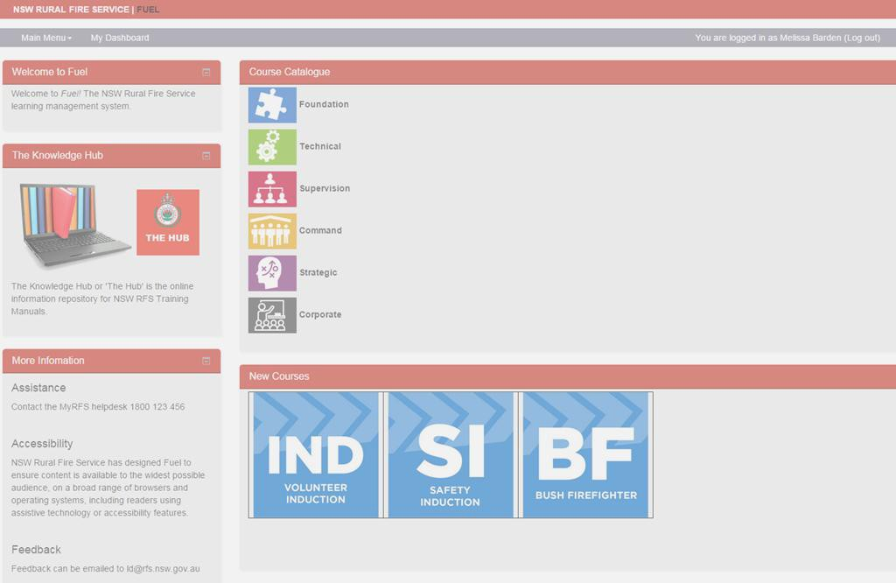
1
1. Click the ‘Log out’ text in the top right hand corner

Accessing and completing courses

Members
!
Fuel interface
Members should familiarise themselves with the Fuel interface. A detailed view can be found at Appendix A.

STEP
1
Once you are on the Fuel homepage you can access a course via the ‘Course Catalogue’. Select from foundation through to strategic (currently only foundation courses have been developed into eLearning formats).

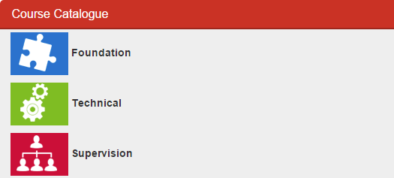
1

1. Click ‘Foundation’

STEP
2
This will take you to the ‘Foundation Courses’ page.
Select the course you would like to work through e.g. ‘Bush Firefighter (BF)’.
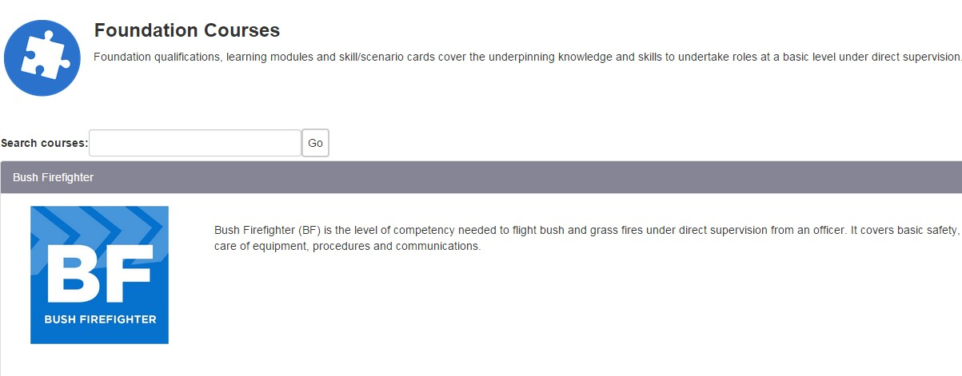
2

2. Click ‘BF’

STEP
3
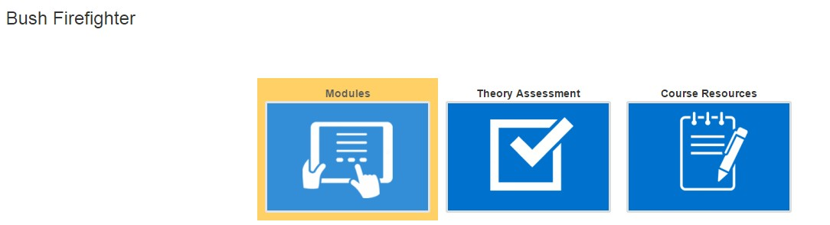
This will take you to the ‘Bush Firefighter’ course homepage. Click on the ‘Modules’ button.
a)
b)
c)
3

3. Click ‘Modules’

a) Modules | Access to all eLearning modules available for course selected
b) Theory Assessment | Access to the theory assessment (this can be completed at anytime)
c) Course Resources | PPT Presentation, Workbook and link to The Knowledge Hub

STEP
4
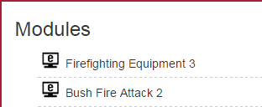
This will take you to the list of modules available for the selected course. Select the module you would like to complete e.g. ‘Firefighting Equipment 3’.
4

4. Click on whichever module you would like to start with

!
Order of Modules
We encourage members to choose which modules they would like to start and finish with. You can skip modules you are already familiar with or start with topics which interest you and move to more challenging topics later or vice versa.
While you are in charge of your learning there are three important things to remember, if you would like to become qualified in a course. In addition to completing the online modules you must follow the steps outlined below:

1 | Complete the online theory assessment
2 | Hone your practical skills – this can be done one of two ways (1) practise your skills back at the brigade by completing the drills outlined in the course skill cards (see Appendix E), or (2) practice your skills by booking in and attending a group or district practical skills training day(s).
3 | Attend and achieve competency in a district assessment event – you must book through your District Officer responsible for Learning and Development.

!
Questions about online course completion
In the first instance, please always speak with your Officer responsible for Learning and Development (also, refer to Appendix F).
SAP
Successful completion of any online assessments will be automatically recorded in SAP (this process may take up to an hour).

Guests
!
Fuel interface
Members should familiarise themselves with the Fuel interface. A detailed view can be found at Appendix B.
Guests only have access to ‘Volunteer induction’ and ‘Safety induction’ courses. The guest log in should not be used by members who have a MyRFS username and password.

STEP
1
Once you are on the Fuel homepage select a course e.g. ‘Safety Induction (SI)’.
1
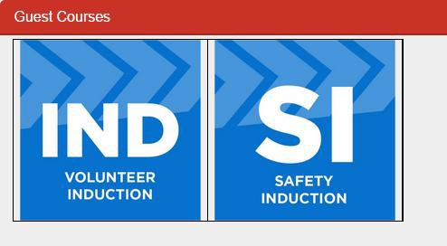

1. Click on ‘Safety Induction (SI)’

STEP
2
This will take you to the list of modules available for the selected course. Select the available module.
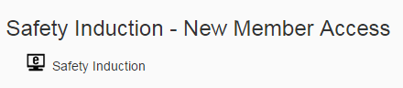
2

2. Click on the available module e.g. ‘Safety
Induction’

STEP
3

This will take you to the eLearning module.
As a guest you must enter your full name into the eLearning package and click ‘Submit’.
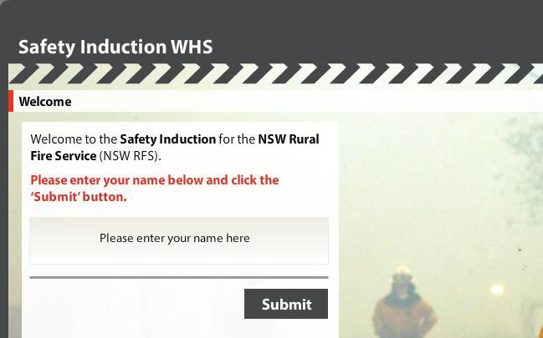
3

3. Enter your full name. This will help your district office in processing your results and course completion details.
Click ‘Submit’

STEP
You will now be able to move your way through the module.
4
When you finish the Module, click print your results (or take a screen shot) and email/deliver- in-person to your district office so your results can be processed into the SAP system.
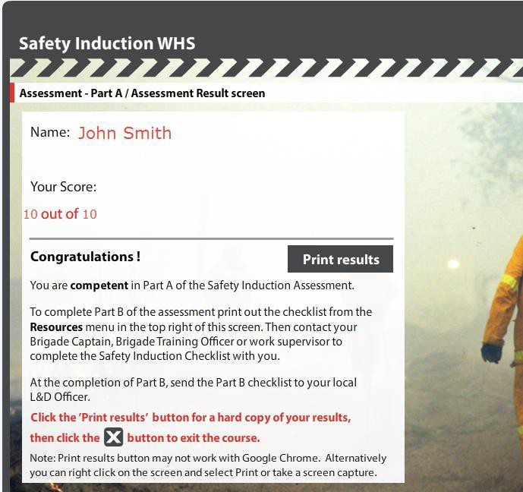
4

4. Click ‘Print results’.
PLEASE NOTE: The Safety Induction (SI) course has a Part B practical component, which must be completed at your brigade to achieve competency.

Help

In the first instance, refer to the Fuel user guide
Email myrfs.support@rfs.nsw.gov.au
Call MyRFS support hotline 1800 123 456

Frequently Asked Questions
The Learning and Development team have put together a list of anticipated frequently asked questions regarding Fuel and the new BF online learning course. If you notice that something important is not covered in this section, please contact LD@rfs.nsw.gov.au.

Fuel

The modules are taking a long time to download – is there an alternative electronic learning method for me to use?
No – there are no alternative electronic learning methods currently available. However, we suggest you try the following if you are experiencing slow downloading times:
› Turn your computer off and on again and re-try the modules
› Try using the modules on a different day to determine whether or not it is a one off occurrence or an ongoing problem. Remember different times during the day (or different days) have peak usage periods, which will directly affect your download speeds.

If you are experiencing difficulties with download speed please email LD@rfs.nsw.gov.au with the subject line ‘Fuel’. Remember for those users using 3G and 4G internet connections you may experience slower download times. Please be advised that face-to-face training is still available for all NSW RFS courses.

Why when I log in to MyRFS do I have to log in to Fuel again? Isn’t this doubling up?

Fuel is hosted outside the NSW RFS network providing a solid, reliable service, which will not impact or be impacted by, the increase use of RFS Operational systems during operational periods.
Essentially, you are required to login to Fuel again because it is a separate system. In the future we hope to find a feasible solution which will allow us to remove the second login screen to improve useability.

When I reset my password for Fuel why am I redirected to the MyRFS password reset page?
Logging in to Fuel requires the same username and password you use for MyRFS, so if you forget your password, the password reset tool will redirect you to MyRFS, as this is where password data is maintained.

Why do I not receive an email when I reset my MyRFS password?

The password reset email is sent to the email address that is recorded on your SAP volunteer record. We advise you to check that the email address listed in your SAP volunteer record is up-to-date.

Bush Firefighter (BF) modules

Can I skip modules on topics I am already familiar with?

Yes. The BF course has been developed using the latest research into adult education, which suggests adults learn best when they are in charge of their own learning.
We encourage members to choose which modules they would like to start and finish with. You can skip modules you are already familiar with or start with topics which interest you and move to more challenging topics later or vice versa.

Do I have to complete all modules before I complete the online theory assessment?

No. The theory assessment can be completed at any time. Remember, you will need to complete practical skills training and achieve competency in a practical assessment (see Appendix F) before you are qualified in BF.

After completing elearning modules, how are my results recorded?

As you move your way through the modules, a tick will appear against those modules, which you have completed. Results will be sent to SAP once you have successfully completed the online theory assessment.

Please note that results may take up to one hour to process and be uploaded into SAP.

Do I have to do both the face-to-face theory training as well as the online training to make sure I cover everything?
No. The online learning covers everything that is covered in the face-to-face training.

Am I missing out if I do the theory component of the course online – wouldn’t I learn more in the classroom?
It really depends on your learning preferences. You can learn the theory component of the course online in a flexible, self-directed way or you can book into a course and learn at set times, in accordance with a set program, in a classroom type setting. It’s up to you! All practical training is still done in face-to-face training formats (see Appendix F).

Members who attend the face-to-face courses receive paper-based training materials. Do I miss out if I complete the theory component of the course online?
No. If you wish (you do not have to) you can download the paper based resources by clicking on the ‘Course Resources’ button (see Step 3, p6). This section will contain the PPT, Workbook, Training Guide, Skill Cards and link to The Knowledge Hub (Appendix G).
Alternatively, you can pick up copies at your local district office.

I am not being permitted to attend district practice training events because I completed the theory component of the course online. What should I do?
In the first instance please refer the matter to your District Officer responsible for Learning and Development. If you feel that the matter has not been adequately resolved you may refer the matter to your District Manager.

I am not being permitted to attend a district assessment event because I completed the theory component of the course online. What should I do?
In the first instance please refer the matter to your District Officer responsible for Learning and Development. If you feel that the matter has not been adequately resolved you may refer the matter to your District Manager.

Feedback
The Learning and Development team are always looking for ways to improve our education products and systems. If you have constructive feedback or ideas on how we can make our products or systems more user friendly, please email LD@rfs.nsw.gov.au.

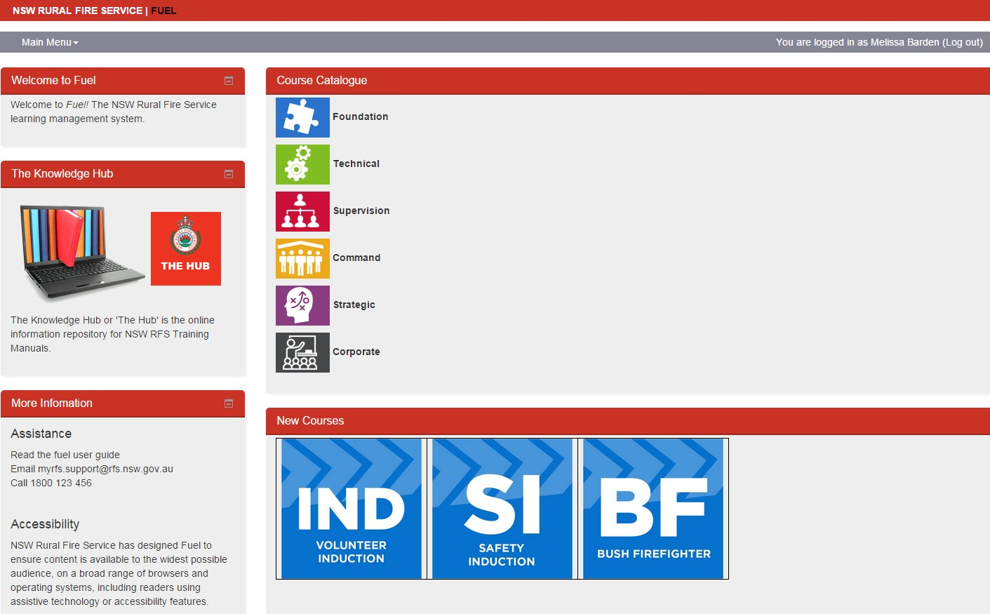

Appendix A – Fuel interface (Members)

1 2

3

4

5

6

UNDERSTANDING THE FUEL INTERFACE
DESCRIPTION |  | FUNCTIONALITY
1 | Main Menu | The ‘Main Menu’ button can be used at anytime to return to the homepage screen.
2 | Log out | The ‘Log out’ button can be used at anytime to log out of Fuel.
3 | Course Catalogue | The ‘Course Catalogue’ organises online courses available in Fuel into the NSW RFS Training Framework (see Appendix D). As more online courses are made available to members the ‘Course Catalogue’ will become a useful tool to find the particular course you are looking for.  Click on any level within the NSW RFS Training Framework to view the courses currently available online.
4 | The Knowledge Hub | ‘The Knowledge Hub’ is the information repository for NSW RFS Training Manuals. As courses are made available online, the corresponding face-to-face training manual equivalent will be uploaded to ‘The Hub’ making the information readily accessible in a searchable, printable format (see Appendix G)  Click on ‘The Hub’ icon to be redirected.
5 | More Information | The ‘More Information’ section lists the different ways users can access help and support. In the first instance users should always refer to the Fuel user guide.
6 | New Courses | The ‘New Courses’ section lists all new courses added in the last three months. As more online courses are made available to members the ‘New Courses’ section will become a more useful tool.

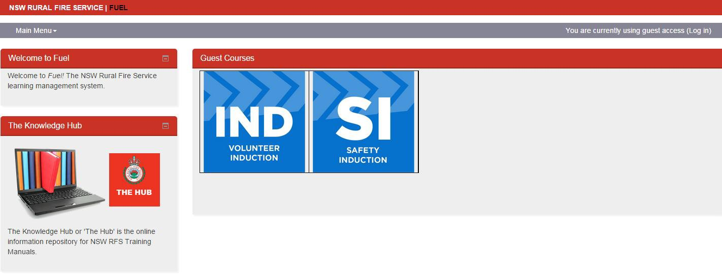
Appendix B – Fuel interface (Guests)
1
2
3

UNDERSTANDING THE FUEL INTERFACE
DESCRIPTION |  | FUNCTIONALITY
1 | Main Menu | The ‘Main Menu’ button can be used at anytime to return to the homepage screen.
2 | Guest Courses | The ‘Guest Courses’ section displays the courses currently available to guests i.e. Volunteer Induction (IND) and safety Induction (SI).

3 | The Knowledge Hub | ‘The Knowledge Hub’ is the information repository for NSW RFS Training Manuals. As courses are made available online their face-to-face training manual equivalent will be uploaded to ‘The Hub’ making the information readily accessible online in a searchable, printable format (see Appendix G).  Click on ‘The Hub’ icon to be redirected.

Appendix C – MyRFS password reset

STEP
1

1. Click ‘Password reset’
Remember because you use your MyRFS password to login, you will be redirected to the MyRFS site to retrieve your login details.
PLEASE NOTE: To avoid delay make sure your email address is up to date. Your username and password will be sent to you rnominated account.

Guest log in
Commercial training log in

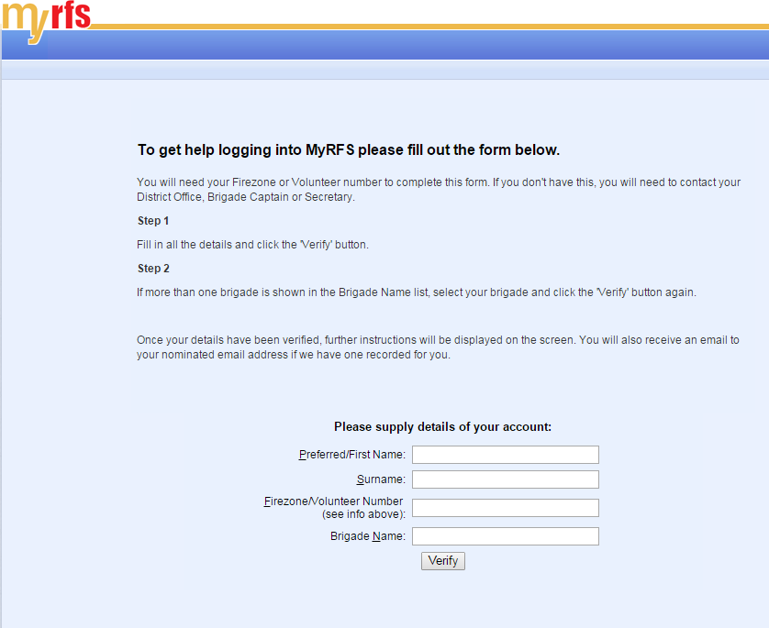
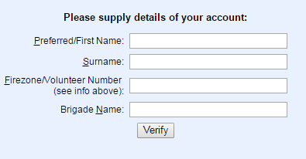
STEP
Password reset
2
2. Enter your details and click ‘Verify’.
Further instructions will appear on your screen.
2
1

Appendix D – NSW RFS Training Framework
The NSW RFS training framework consists of five training levels from foundation through to strategic. Each level contains multiple training courses, allowing members to gain valuable experience and knowledge, equipping them with the skills needed for different roles within the NSW RFS. Each training course has a reference manual which contains the theoretical knowledge required to complete the qualification.

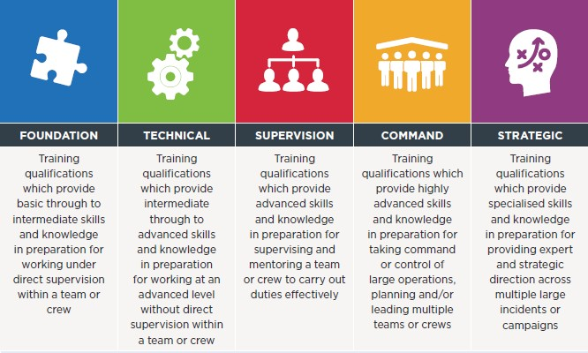

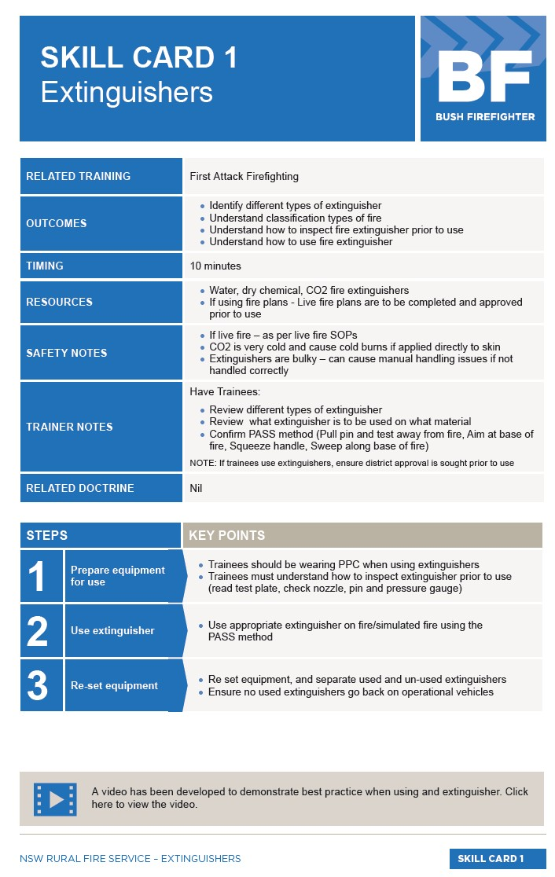
Appendix E – Skill cards

Skill Cards
Skill cards are used to help trainees hone their practical skills.
The skill cards were created to assist local trainers and brigade members support trainees learn the practical skills for their courses.
Benefits
- Clear directions
- Supports embedded knowledge and skill

Where can I download skill cards?
Skill cards are available via Fuel in the ‘Course Resources’ section (please see Step 3, p. 6).

| SAMPLE SKILL CARD ONLY |

Appendix F – BF online course completion Vs face-to-face course completion
Below is a simplified flowchart detailing the most common pathways to complete Bush Firefighter (BF). It is important to understand that as long as you (1) achieve competency in the theory assessment (online, paper-based or verbal), (2) practice your skills (at group/district skills training events or with your brigade) and (3) achieve competency at a scheduled district assessment, you will become qualified in BF.

FACE TO FACE DISTRICT TRAINING
VS

ONLINE MODULES

ATTEND PRAC SKILLS TRAINING

COMPLETE PAPER- BASED THEORY ASSESSMENT

COMPLETE ONLINE THEORY ASSESSMENT

COMPLETE PRACTICAL ASSESSMENT EVENT

!
Practical training
Online courses typically only cover the theory components of NSW RFS courses. You must (in most cases) participate in practical training to achieve competency and gain a qualification.

Skill Cards
Skill cards should be used when completing practical training back at your brigade or during district practical skills training (See Appendix E).

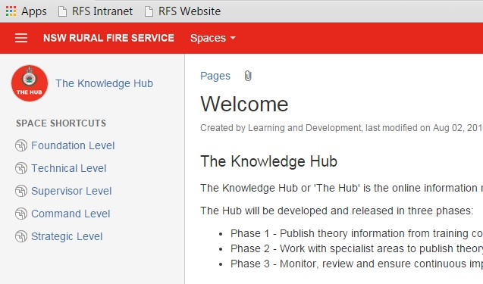
Appendix G – The Knowledge Hub
2
The Knowledge Hub, or simply ‘The Hub’ is the online information repository for NSW RFS Training Manuals.
Benefits of The Hub:
› Accessible: Members no longer need to wait for a formal course to begin learning.
› Up-to-date: The Hub’s structure makes it easy to make changes, so members will always be able to access the most up-to-date information.
› Functional: Members can use the search bar to navigate their way to the information they need quickly.

Accessing The Hub

STEP
1
To access The Hub log in to Fuel (see Logging in and out p.4) Select ‘The Hub’ icon
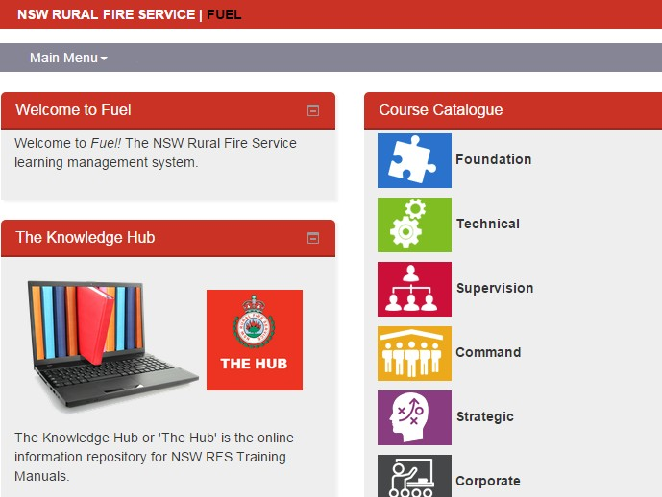
1

1. Click ‘The Hub’ icon

STEP
2
This will take you to ‘The Hub’ landing page.
Select from the space shortcuts on the left e.g. Foundation

2. Click ‘Foundation’

\STEP
3
This will take you to the Foundation landing page.
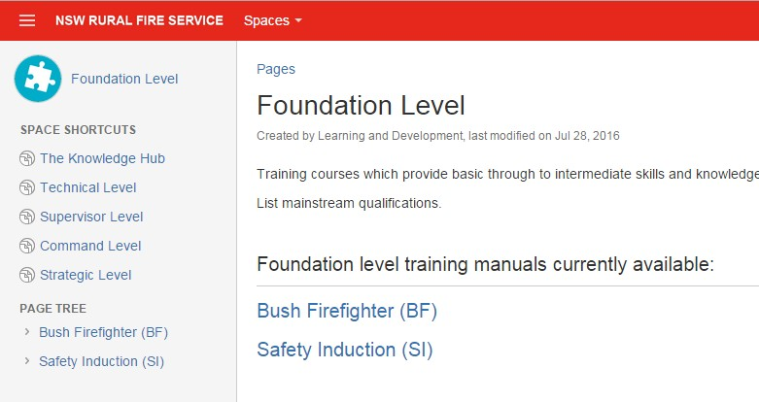
Select from the available NSW RFS Training Manuals available, e.g. Bush Firefighter (BF).
3

2. Click ‘Bush Firefighter’

